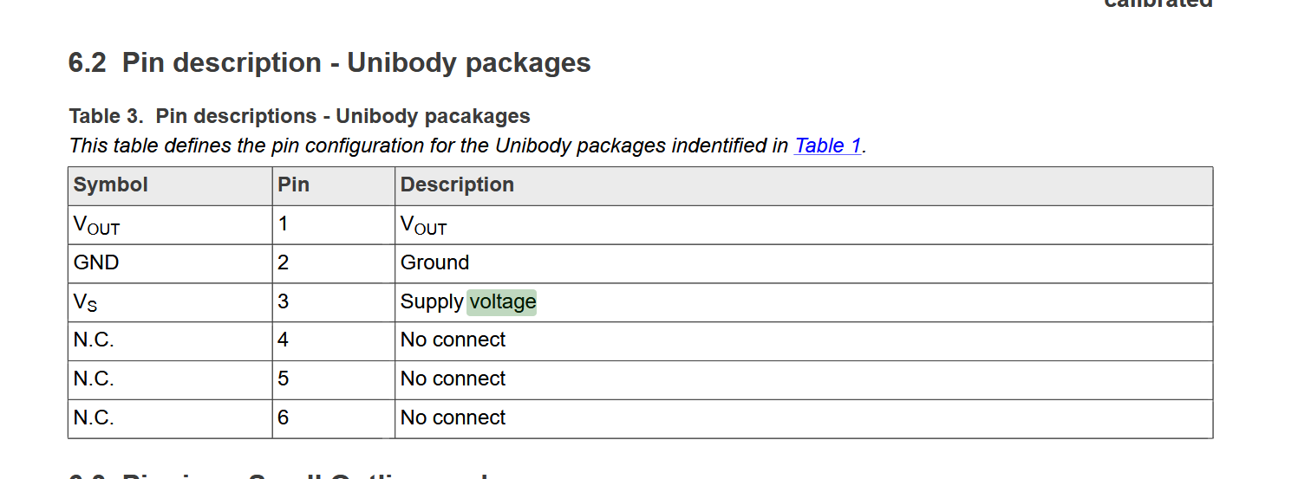
Pin 1 is leftmost when text is on top of part, pressure inlets pointing away from you

